1: Test connectivity using Ping

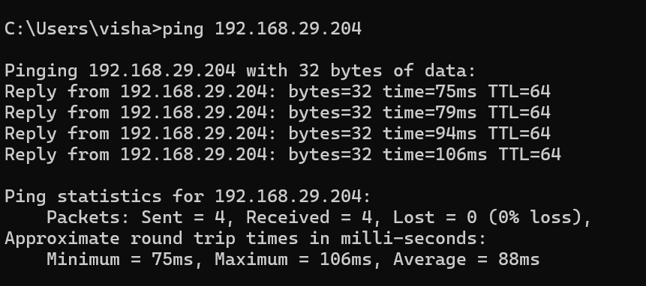
I connected my laptop and my friend's phone to the same Wi-Fi network. I used the ping command in Windows Command Prompt to test connectivity with IP address 192.168.29.204. I received all four replies, with 0% packet loss and an average response time of 88 ms. This indicates that the target device responded successfully to the ping test.

2: Run Traceroute to YouTube

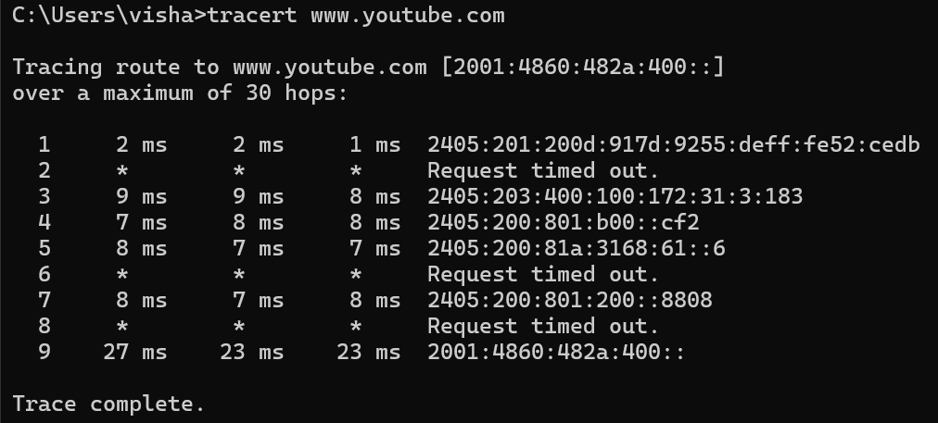
3: Disconnect a device and test Ping again

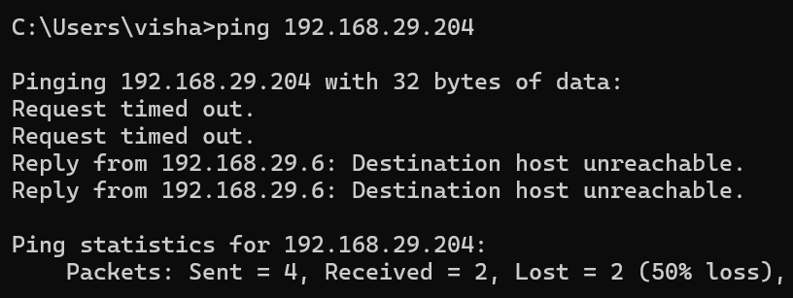
When the phone disconnects from Wi-Fi, it normally cannot respond to pings sent over that Wi-Fi connection.

4 : Table of Connected Devices
Sr. No. | IP Address | Physical Address (MAC) | Device
1 | 192.168.29.1 | 90-55-de-52-ce-db | Wi-Fi Router
2 | 192.168.29.204 | fe-c8-82-87-7d-cb | My phone
3 | 192.168.29.237 | 1c-d6-be-ad-63-70 | Unknown device

5 : Report on Wi-Fi Network Setup and Connectivity Testing

1. Network Setup
First, I connected my Windows 11 laptop to my home Wi-Fi network. My laptop's IP address was 192.168.29.6. I used the ipconfig and arp -a commands to check network information and view the IP addresses of discovered devices.
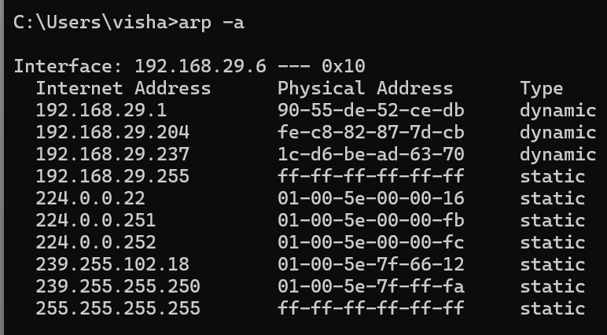

2. Ping Test
I used the command ping 192.168.29.1 to test connectivity with my Wi-Fi router. The command sent four packets and received all four packets. There was 0% packet loss, and the average response time was 2 milliseconds.
This result showed that my laptop could communicate successfully with the router.
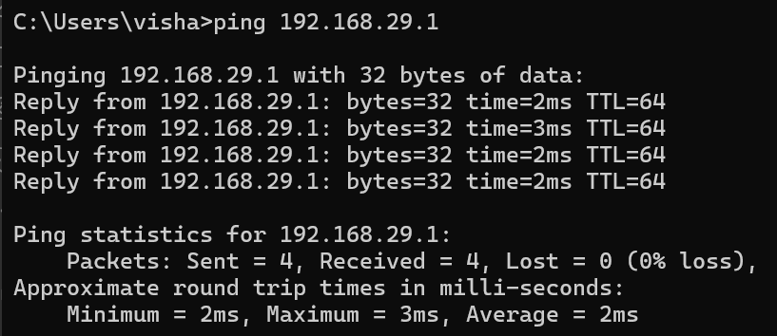

3. Traceroute Test
I used the command tracert google.com to trace the network path to Google's server. The command displayed 22 hops and ended with the message "Trace complete."
Some hops showed "Request timed out" because some routers did not respond to traceroute requests. However, the trace reached the destination successfully.
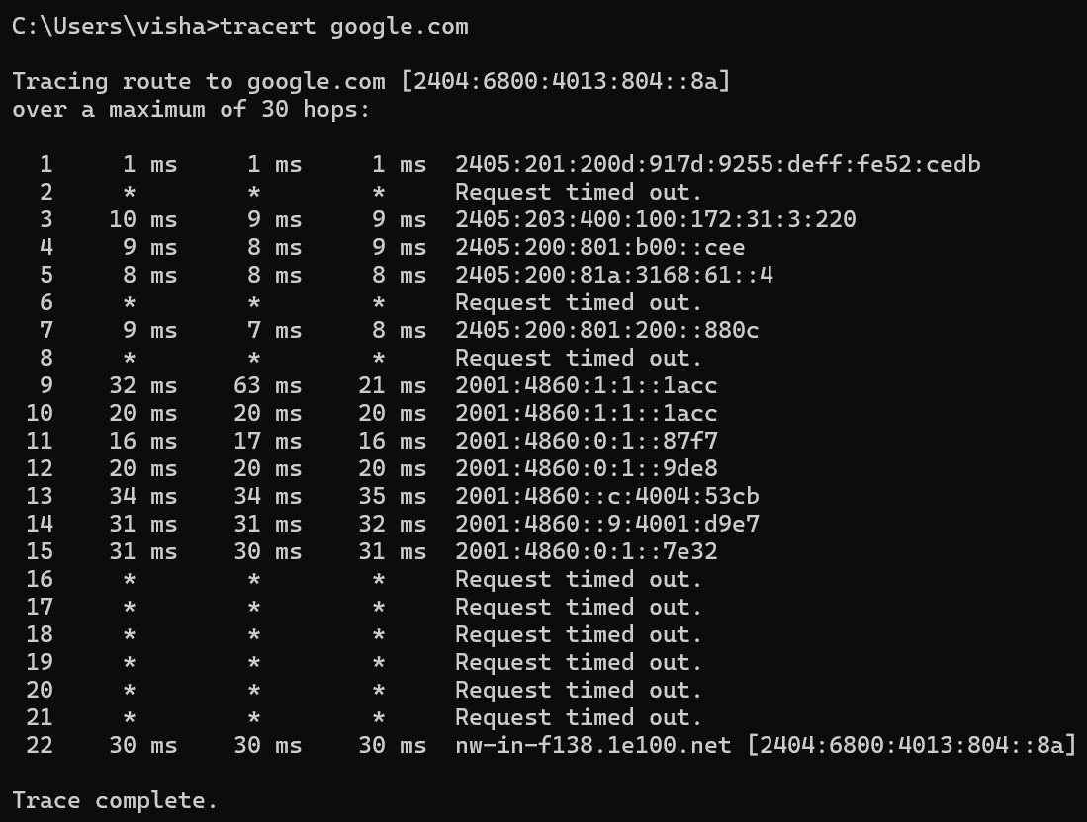

4. Results and Issues
Both networking commands worked successfully. The ping test showed a stable connection to my router with no packet loss. The traceroute test showed the route towards Google's server, although some intermediate routers did not respond.

5. Conclusion
This activity helped me understand how to check IP addresses and test network connectivity using Windows commands. I learned how to use arp -a, ping, and tracert for basic network troubleshooting.

